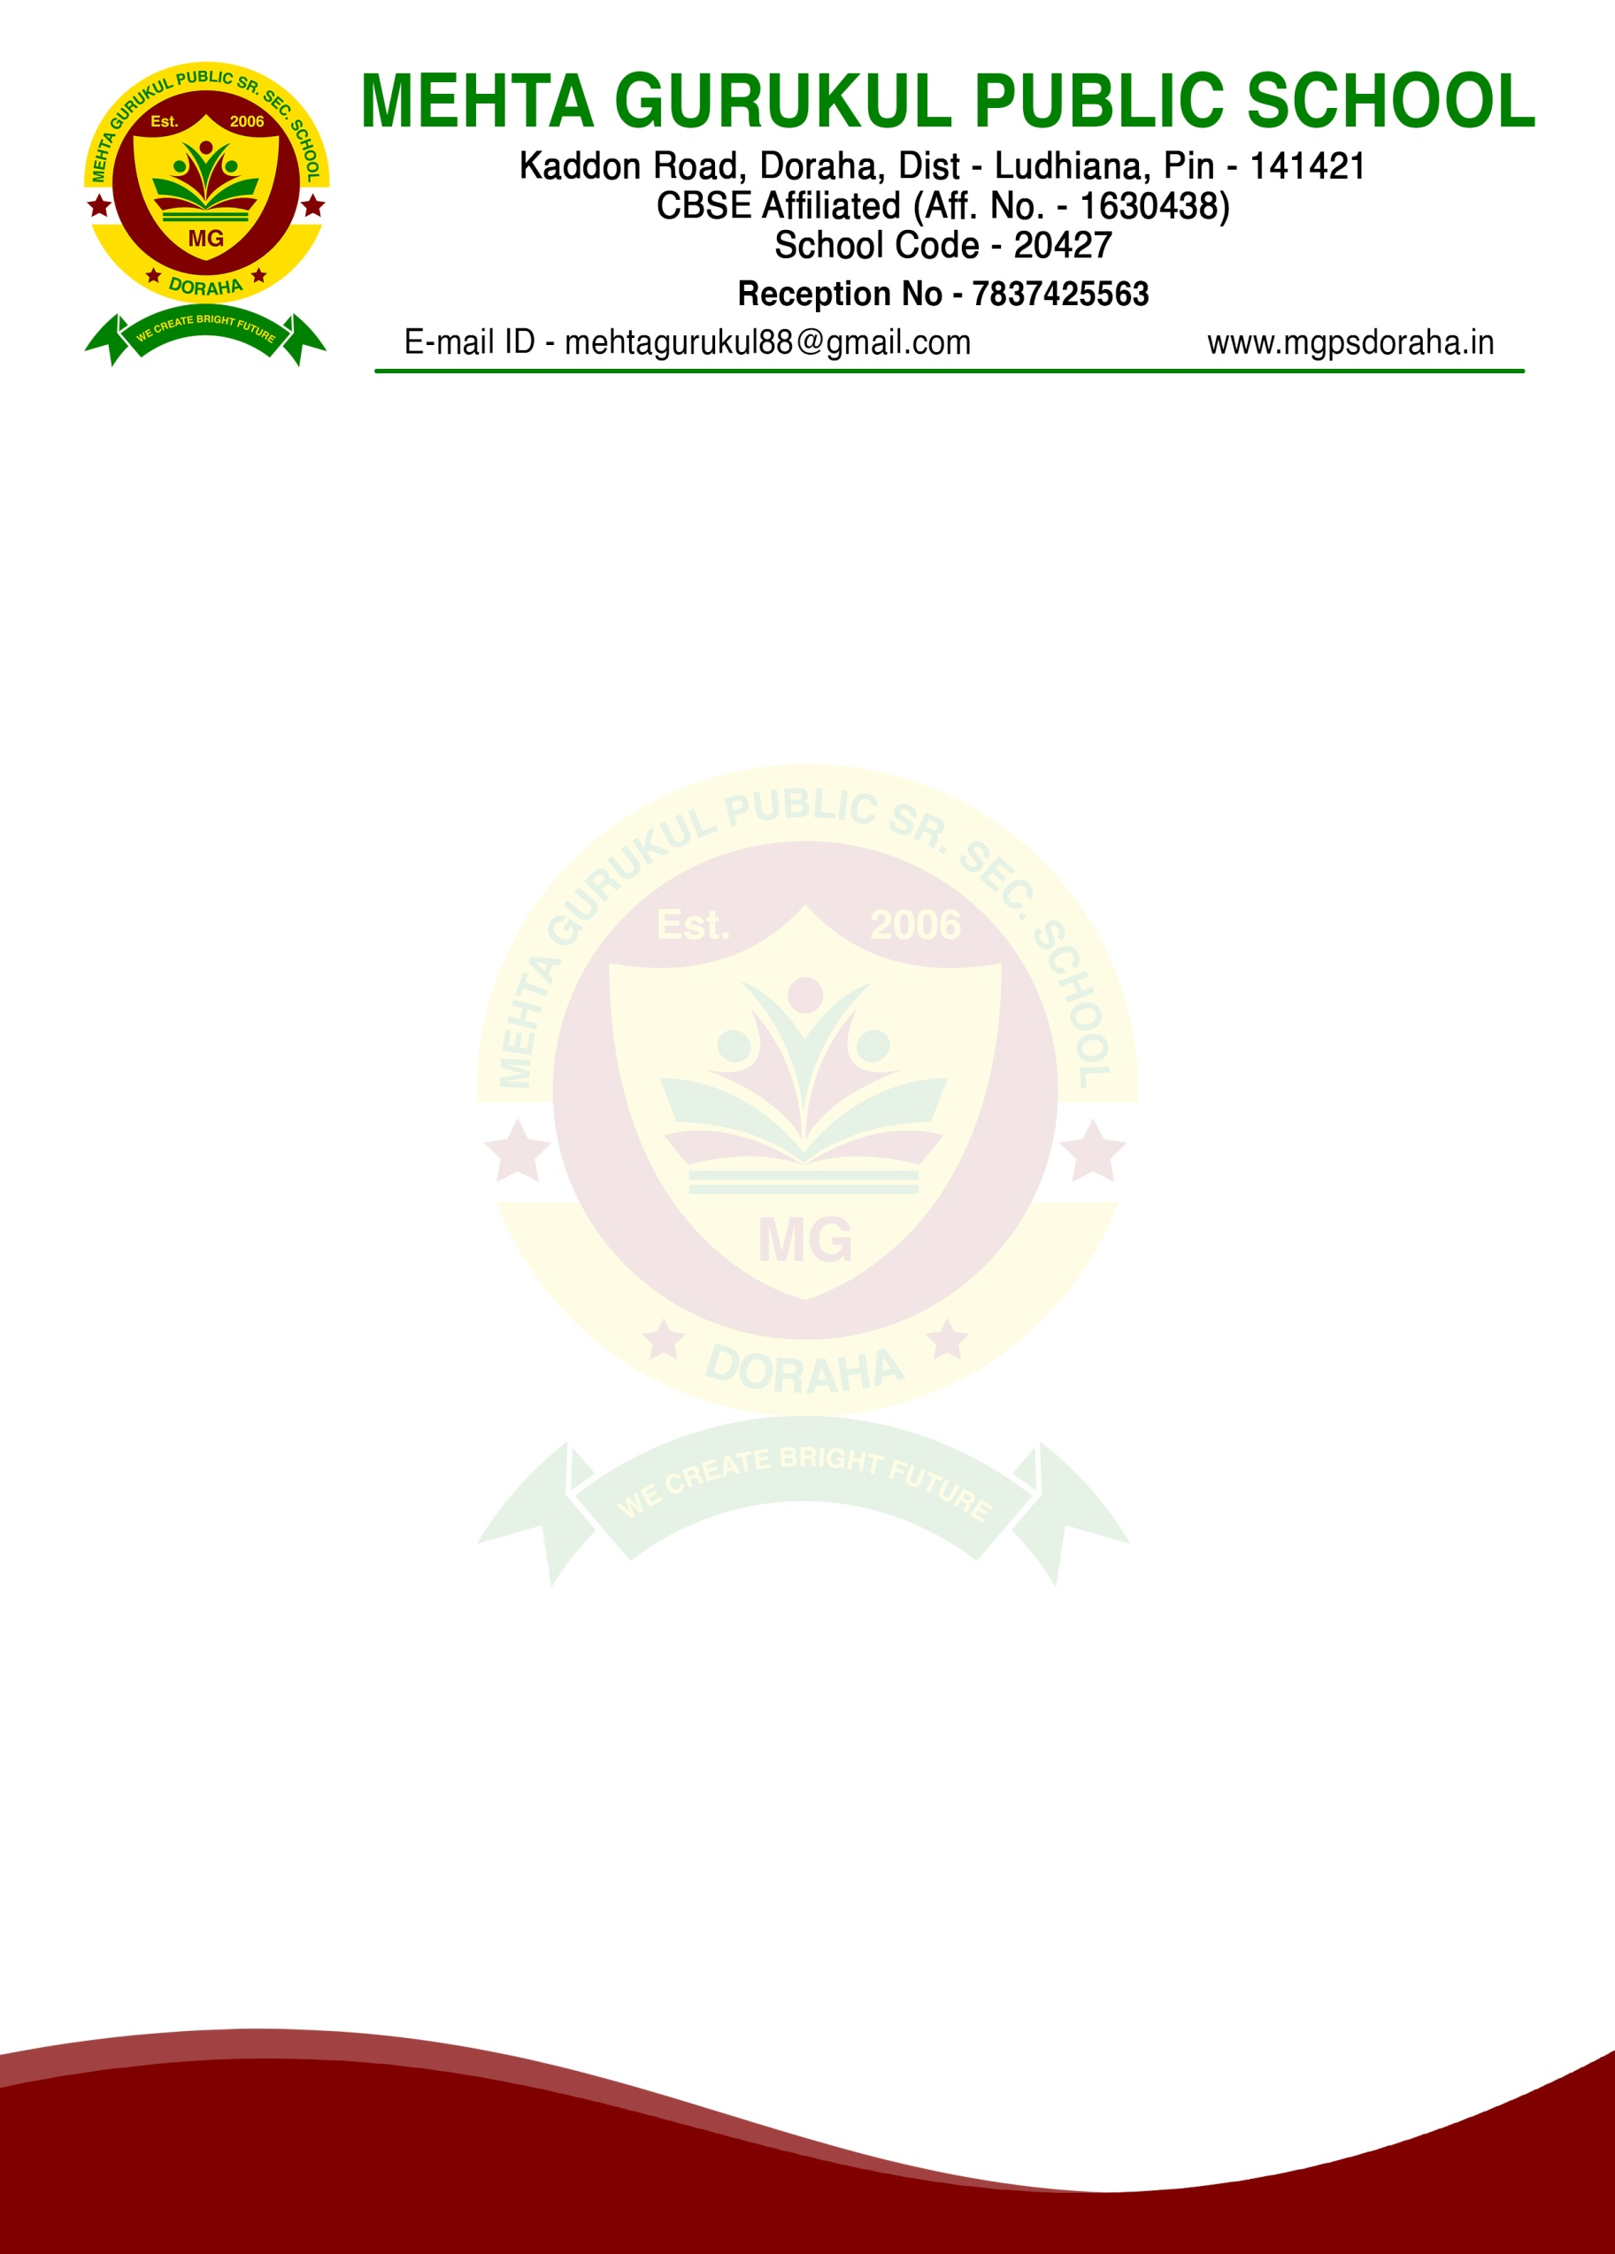

MEMBERS OF PTA COMMITTEE
S.NO. | NAME | OCCUPATION | DESIGNATION
1 | MRS. DIMPLE MEHTA | PRESIDENT | PRESIDENT
2 | MRS.NEHA | PRINCIPAL | PRINCIPAL
3 | MR.JAGJEET SINGH | COORDINATOR | MEMBER
4 | MRS.KAMALJEET KAUR | COORDINATOR | MEMBER
5 | MRS.ARSHPREET KAUR | TEACHER | MEMBER
6 | MS.GAGANDEEP KAUR | TEACHER | MEMBER
7 | MRS.NAVNEET KAUR | PARENT | MEMBER
8 | MR.JASPREET SINGH | PARENT | MEMBER
9 | MRS.MANPREET KAUR | PARENT | MEMBER
10 | MRS.DAVINDER KAUR | PARENT | MEMBER

